Tracking of production batches through the factory processed

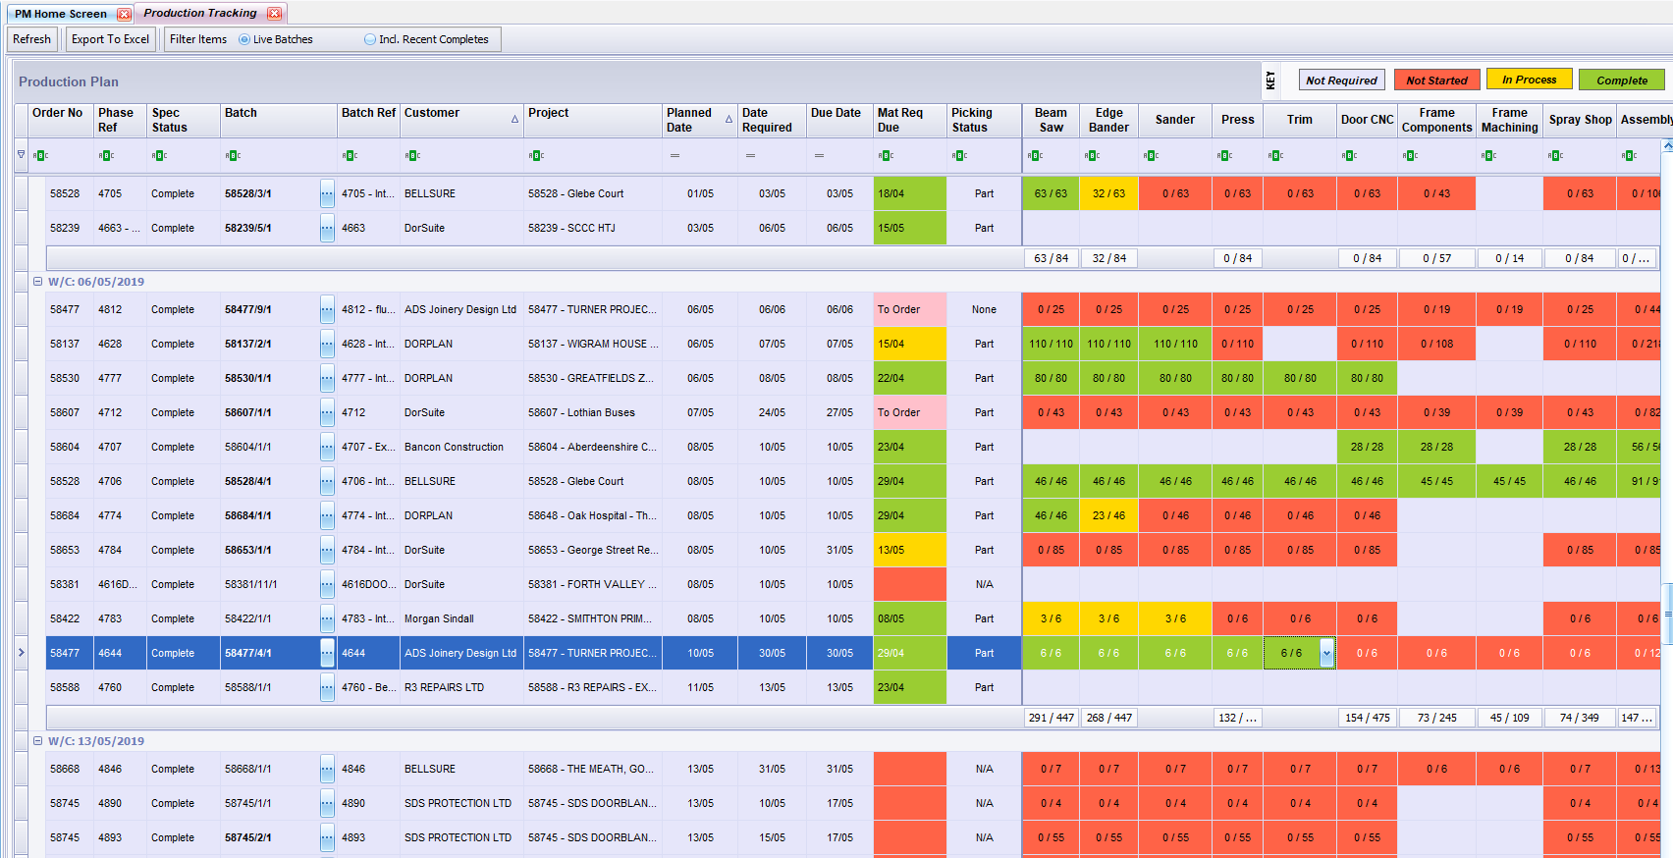

Checking that all materials have been purchased – double click a cell pops up the window – the Mat Req Due field in the previous page is fed from here e.g. goes green when all material are available

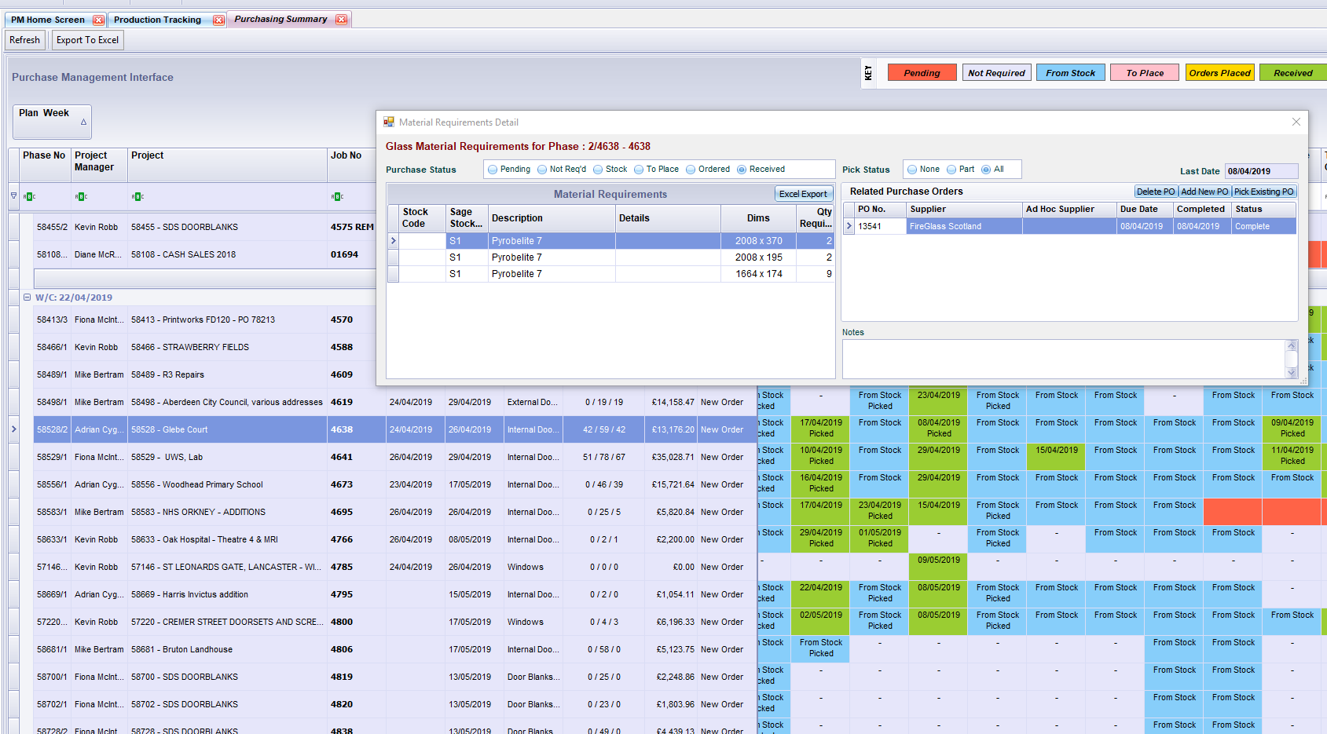

Overview of Jobs as they go through various milestones – this is the highest-level spanning across what all the departments need to do so that the job can progress. There is an target date which calculates based on some very basic rules of thumb. Material Ordered a week before Production which is two weeks before despatch – so they can fill in a target production complete date, and it sets targets back upstream (that can be tweaked if required) then we record the actual (the little number underneath is the number of days before or after the target this milestone was actually reached.

